ManipuLogic System Design

Table of Contents

Static Views 1

Dynamic Views 1

Deployment/Environmental Views 1

# Static Views

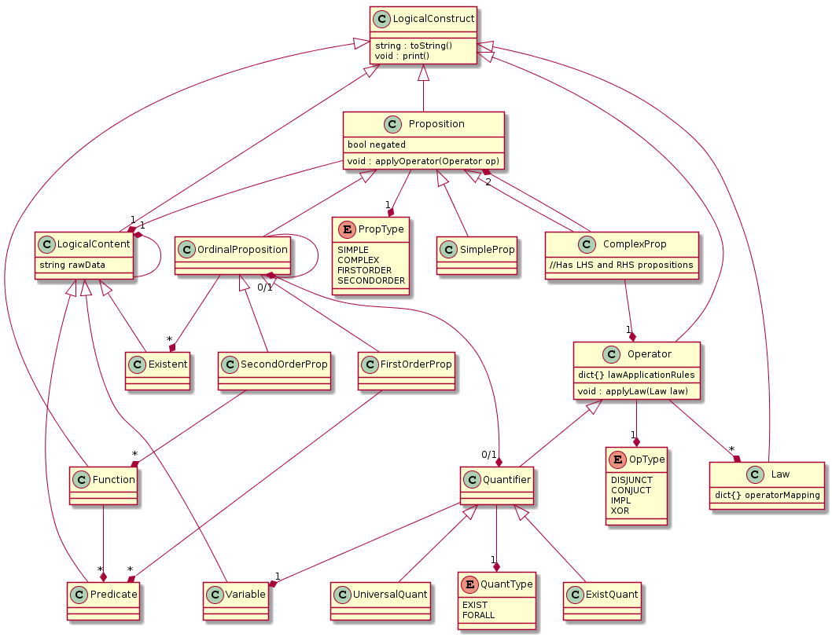

Figure -- Class Diagram of ManipuLogic

# Dynamic Views

# Deployment/Environmental Views